**DAILY ASSESSMENT FORMAT**

|  |  |  |  |
| --- | --- | --- | --- |
| **Date:** | **17/07/2020** | **Name:** | **Yashaswini.R** |
| **Course:** | **Mathematics for machine learning: Linear Algebra** | **USN:** | **4AL17EC098** |
| **Topic:** | **Eigenvalues and Eigenvectors: Application to Data Problems** | **Sem &Sec:** | **6th sem ‘B’ sec** |
| **Github Repository:** | **Yashaswini** |  |  |

|  |
| --- |
| **FORENOON SESSION DETAILS** |

**IMAGE OF SESSION**

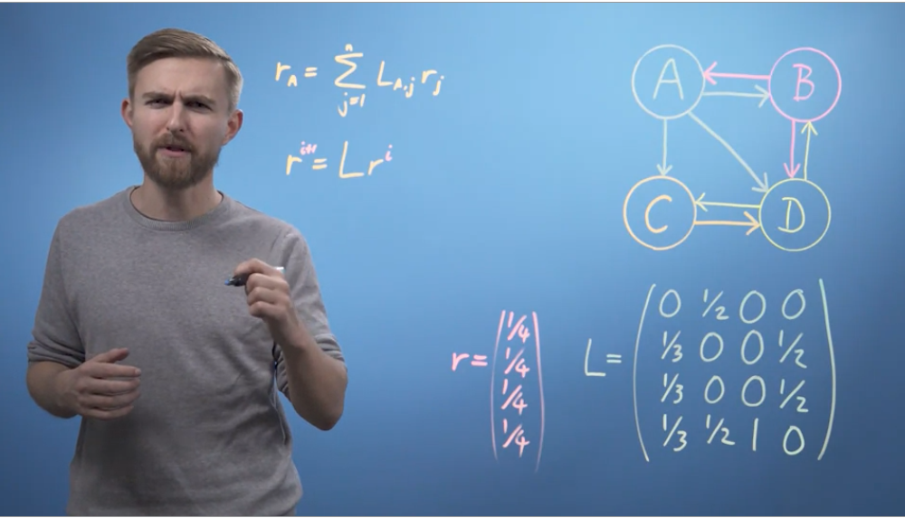

**Eigenvalues and Eigenvectors**:

* An eigenvector, corresponding to a real nonzero eigenvalue, points in a direction in which it is stretched by the transformation and the eigenvalue is the factor by which it is stretched.
* If the eigenvalue is negative, the direction is reversed. Loosely speaking, in a multidimensional vector space, the eigenvector is not rotated.
* If T is a linear transformation from a vector space V over a field F into itself and v is a nonzero vector in V, then v is an eigen vector of T if T(v) is a scalar multiple of v.
* This can be written as where λ is a scalar in F, known as the eigenvalue, characteristic value, or characteristic root associated with v.
* There is a direct correspondence between n-by-n squarematrices and linear transformations from an n-dimensional vector spaceinto itself, given any basis of the vector space.
* Hence, in a finite-dimensional vector space, it is equivalent to define eigenvalues and eigenvectors using either the language of matrices or the language of linear transformations.
* If V is finite-dimensional, the above equation is equivalent to where A is the matrix representation of T and u is the coordinate vector of v.In essence, an eigenvector v of a linear transformation T is a nonzero vector that, when T is applied to it, does not change direction.
* Applying T to the eigenvector only scales the eigenvector by the scalar value λ, called an eigenvalue.
* This condition can be written as the equation referred to as the eigenvalue equation or eigenequation.
* In general, λ may be any scalar. For example, λ may be negative, in which case the eigenvector reverses direction as part of the scaling, or it may be zero or complex.
* Linear transformations can take many different forms, mapping vectors in a variety of vector spaces, so the eigenvectors can also take many forms.
* The linear transformation could take the form of an n by n matrix, in which case the eigenvectors are n by 1 matrices.
* If the linear transformation is expressed in the form of an n by n matrix A, then the eigenvalue equation above for a linear transformation can be rewritten as the matrix multiplication where the eigenvector v is an n by 1 matrix.
* For a matrix, eigenvalues and eigenvectors can be used to decompose the matrix, for example by diagonalizing it.